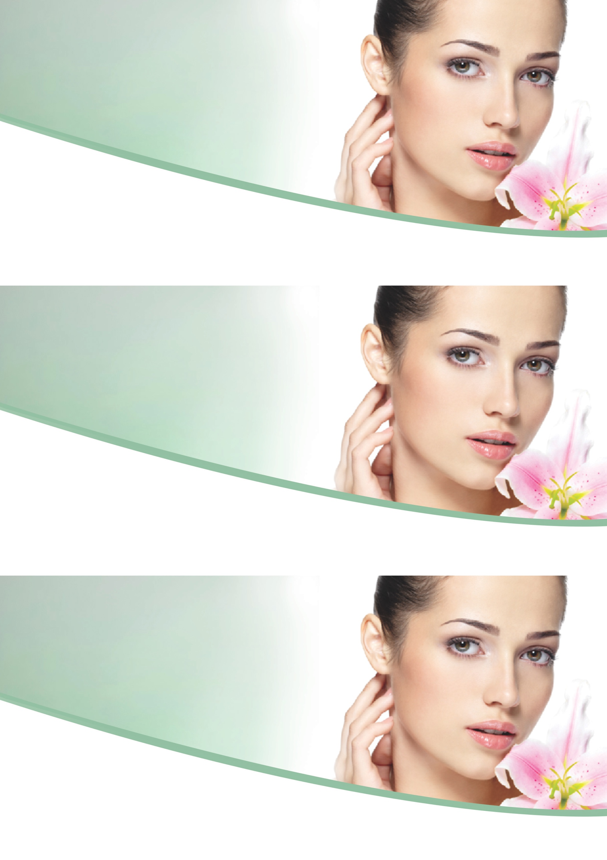
How are your eyebrows? Too light, can’t see them? Unruly Shape?

Do your eyelashes have the wow factor?
Did you know we can tint your eyebrows and eyelashes whilst your colour is being rinsed off?

We can also do an eyebrow wax/sculpt!

How are your eyebrows? Too light, can’t see them? Unruly Shape?

Do your eyelashes have the wow factor?
Did you know we can tint your eyebrows and eyelashes whilst your colour is being rinsed off?

We can also do an eyebrow wax/sculpt!

Did you know we can tint your eyebrows and eyelashes whilst your colour
is being rinsed off?

We can also do an eyebrow wax/sculpt!
ENCHANTING EYES
ENCHANTING EYES
ASK OUR TEAM NOW
ASK OUR TEAM NOW
ASK OUR TEAM NOW
ENCHANTING EYES
ONLY $XX
ONLY $XX
How are your eyebrows? Too light, can’t see them? Unruly Shape?

Do your eyelashes have the wow factor?
Did you know we can tint your eyebrows and eyelashes whilst your colour is being rinsed off?

We can also do an eyebrow wax/sculpt!

ONLY $XX

