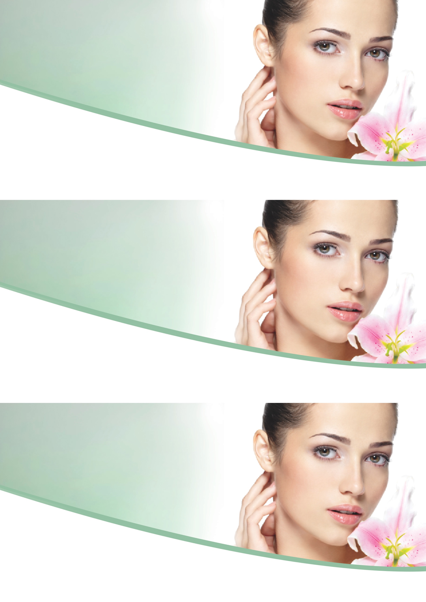
YOUR EYES WILL THANK YOU
YOUR EYES WILL THANK YOU
Aaaahhhh, it’s nice at the basin. Relaxing, eyes closing.
Why not make most of the time and have a hydrating and revitalising under eye mask whilst you’re here?
About to head to the basin?
Relaxing, eyes closing.
Why not make most of the time and have a hydrating and revitalising under eye mask whilst you’re here?
ASK OUR TEAM NOW
ASK OUR TEAM NOW
ASK OUR TEAM NOW
UNDER EYE ALGEA MASK
WHY NOT REFRESH THOSE EYES WHILST YOU’RE THE AT THE BASIN?
ONLY $XX
ONLY $XX
ONLY $XX

